Interview, the mother of Sanne

General questions:

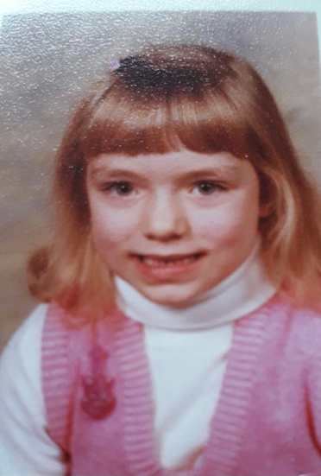

Judith, 46 years old, F

- How many people were there in your parents family? How many people lived in the same house? Nuclear or extended family?
I lived with my father and my mother, so in total with three people. I lived with my father and mother in the same house.
- What was the profession of your father and mother?
My father was accountmanager. My mother worked as a secretary for the company where my father worked. She has also worked as an optician in a contactlenses store.
- Where did you live with your parents (please add map - Google Maps).
I lived in Rotterdam, near to the stadium of Feyenoord.
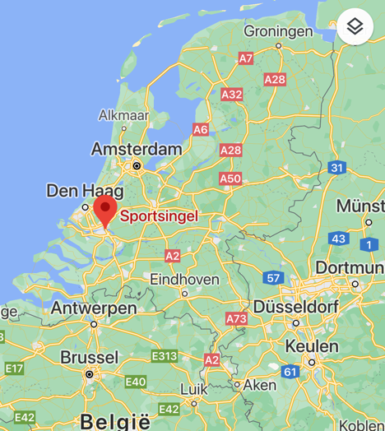
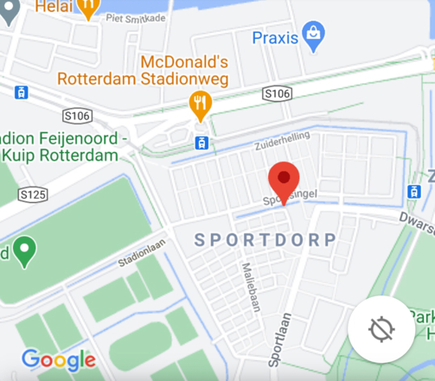

- Do you remember any historical fact / event when you were a teenager (between 12 and 16 years old) either in India or in EU or worldwide. Why were you impressed by that event?
In April 1986 the Chernobyl disaster took place. There was an explosion in a nuclear power plant, which also had a major impact on Europe. All kinds of radioactive particles were released. We were afraid that that radiation would also reach Europe, so it had a major impact. We were not only afraid of it, but at one point they also measured radioactive particles in the Netherlands. I was worried it would affect my health. As a child I placed this in the light of the cold war which I found a very exciting time (threat of nuclear weapons). This happened when I was almost 12 years old.

Specific questions of the topic; Healthy Life:

- According to the standards of the time when you were a teenager was the food served in your family healthy? Explain.
Yes, I always got fresh vegetables, potatoes and meat. Actually, according to today's drive of five.
- Where did the family buy the food (market, local shops, supermarkets, farms)? Did your family produce any food itself?
We bought our food from the local supermarket, greengrocer, butcher and bakery. Sometimes we ate tomatoes from our garden, but no other vegetables were grown.
- Did the family members practice some sports/exercise to stay fit? What kinds of sports/exercise did you do?
My mother did jazz ballet and my father ran. I did gymnastics and swimming. We regularly went for walks nearby my home and in the Kralingsebos.
- Where there sufficient facilities to practice sports/exercises (gymnasiums, yoga, aerobics centres, walking tracks etc…)? Photograph exercises.
There were enough facilities to stay fit. There used to be boot camps in the two-hill park. Also there were gyms, sports parks and sports halls where you could move. There was a pool where I got lessons and went swimming freely. I had sports days on the Feyenoord training fields.
- What did the school do to make children to stay fit?
My school provided swimming lessons. We often had sports matches with other schools. We also had a separate sports teacher who taught us. By default, we took part in the four-day evening where we walked 5 kilometers every night. This was all organized by default from the school.
- Do you think that children nowadays have a healthier lifethan in your time?
Certainly not because there used to be a lot more attention for playing outside, sports were organized from school and in the past there was no gaming at all. I used to go out with the neighborhood kids after school and play after dinner. Many children of this time just sit at home playing games. I do think there is more attention to the quality of the food these days.

Interview, grandfather of Sanne

General quetions:

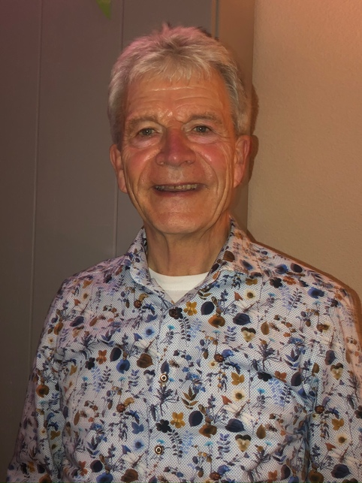
Gerard, 73 years old, Male
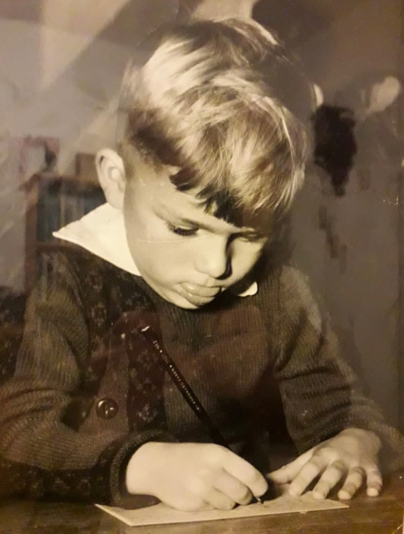
- How many people were there in your parents family? How many people lived in the same house? Nuclear or extended family?
Originally I lived with 5 people. My father sailed on the Rhine with his own ship and was not often at home. So actually I lived with my mother and my 2 brothers, so a total of 4 people. I lived in the same house with my mother and my two brothers.
- What was the profession of your father and mother?
My mother was a housewife and she took care of the children.
- Where did you live with your parents (please add map - Google Maps).
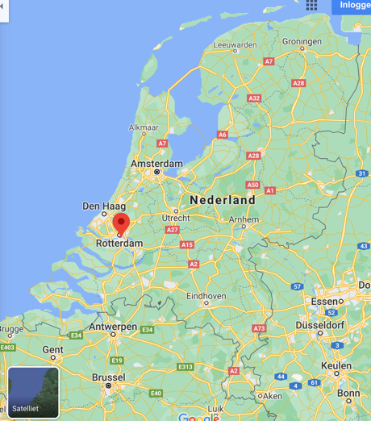
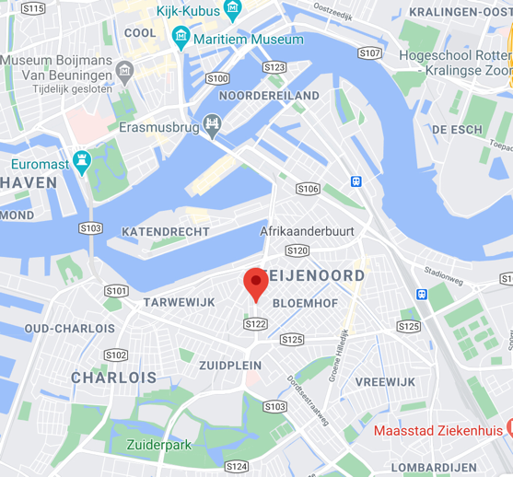
I lived in Rotterdam on the Dordtselaan.

- Do you remember any historical fact / event when you were a teenager (between 12 and 16 years old) either in India or in EU or worldwide. Why were you impressed by that event?
Not when I was around the 14 years old, but I can remember a historical fact when I was a bit younger. I was 6 years old and then the flood disaster happened. In my street, a number of houses were flooded with water. At our home, awnings fell down due to the storm and wind. As a child it made a big impression because it affected the world and it was all over the news. This is something never happens again in your life.

Specific questions of the topic; Healthy Life:

- According to the standards of the time when you were a teenager was the food served in your family healthy? Explain.
I always got fresh food. So vegetables and fruit. I drank fresh milk and ate cheese and eggs. At the time, that was normal eating. You couldn't actually buy unhealthy food like now.
- Where did the family buy the food (market, local shops, supermarkets, farms)? Did your family produce any food itself?
We didn't have supermarkets at the time, but we bought our food from all the local stores. The baker and the milkman came to the door.
- Did the family members practice some sports/exercise to stay fit? What kinds of sports/exercise did you do?
I used to go to the Boy Scout where we had sports days. We would go high jump, long jump, play football and much more. Once I won the running race, where I was the fastest in Rotterdam, of the youth. My brothers were also in Boy Scouts and did the same thing as I did. We also used to cycle. My middle brother played football at Feyenoord, with a youth team. I had swimming lessons, but we had to travel far to get there, because it was not close to my house. The swimming pool was close to Blijdorp Zoo.
- Where there sufficient facilities to practice sports/exercises (gymnasiums, yoga, aerobics centres, walking tracks etc…)? Photograph exercises.
There used to be sports fields near the football stadium. Now there are many more facilities to do sports. There were also two indoor pools where you could swim. Further there was nothing.
- What did the school do to make children to stay fit?
I got gymnastics in school, but not anything else was done. That was just the case at the time. Very simple.
- Do you think that children nowadays have a healthier lifethan in your time?
I don't think so. There is a lot of sport, there are many more options, but on the other hand, children eat very unhealthy food (for example, fast food) which was not possible in the past.

