Hi everyone! For this part of the project I’ve interviewed both of my parents, Laila and Mohammed, about their spare time when they were still teens. I thought that interviewing them would be more interesting that interviewing my grand parents, since my parents have migrated from Morocco to the Netherlands and their answers are pretty much differently than what I’m spending my spare time on, so let’s hear their answers!

First my mother’s interview. Laila (L) was born in 1980, which makes her now 40 years old. Get to know her a bit more!
F - How many people were there in your parents’ family?
And how many people lived in the same house?
L - My father had 8 siblings and his parents, and my mother had 5 siblings and her parents. I lived in a household with my parents + plus their nine kids (me included)
F - What was the profession of your father and mother?
L - My dad owned a shop and my mother was a stay at home mom.
F - Where did you live with your parents?
L - as you’ve already said, I lived in Morocco until I was in my early twenty’s and then I moved to the Netherlands. I lived in the northern part of Morocco.
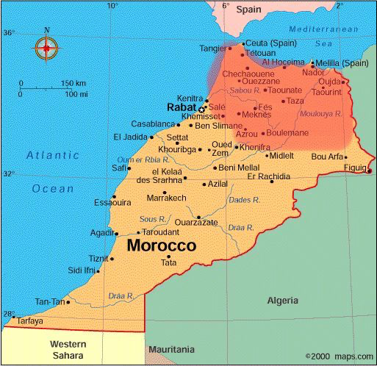
F - Do you remember any historical fact of event when you were a teenager (between 12 and 16 years old) either in India or in EU or worldwide.
L - No I don’t really remember anything special happening.
F - How much spare time did you have when you were a teenager? And during the school week?
L - I had a lot of free time when I was a teenager. During school I always had to do my homework, my mother was a bit strict.
F - And what about in the weekends?
Red region = where my parents lived L - We could do whatever we could in the weekend.
F - What were your favourite hobbies? And did you spend most of your spare time at home or outside?
L - My favourite hobbies were probably reading small stories and comic books, and all that kind of stuff. One time I borrowed a comic book from the library, and I was so invested in them that I forgot to return them. To this day I still have them! And I was most of the time outside.
F - Did you have a lot of spare time or did you have to help your parents a lot?
L - I had a lot of free time, I had older sisters around 20 at the time so they helped my parents, I was the second youngest of nine children.
F - Do you think that you spent your free time well when you were a teenager?
L - Yes, but along the way when I got older, I stayed inside because I felt I was ‘too old’ to stay outside.
F - Did your parents live in a city/ the countryside and how has that influenced how you spent your time as a teenager?
L - My parents lived in the city, but it wasn’t that populated yet. I didn’t affect me a lot because there were a lot of children around my own age whom I could play with.
F - How did you get your pocket money? Could you spend your pocket money yourself? How did you spend it?
L - I rarely got any pocket money, so sometimes I had to ‘politely grab’ some money from my parents and spend it on sweets together with my friends and such.
F - When you were young, did you spend your free time with the children who belonged to your religious and/or social background?
L - Yes, because I grew up in Morocco and I was a native resident. We were from different tribes though.
F - Were there special clubs for children of religious groups or of social groups/castes?
L - No, not really.
F - Did your parents have influence on your spare time?
L - They did have influence, like I couldn’t just disappear outside without asking for permission. Whenever me and my siblings got home late, they’d get pretty angry with us.
F - How much spare time did your parents (parents of the persons interviewed) have when you were a teenager?
L - They didn’t have much free time. My mom’s always busy with her house and children, and my dad was busy with his shop and his children too.
F - What about after work, during the weekend?
L - In the weekend it’s the same story for both.
F - What did they do in their free time?
L - Their free time was mostly around the evening, when everyone was home. We’d sit there with 10+ men (sometimes our neighbors joined in too) and drink some tea and share our stories. My dad would always come back from his shop and take sweets with him to eat with the tea, and we’d always wait for that moment to happen. We’d look at his hands and see the bags full of savoury he’d brought and we’d be very happy. Sometimes he’d joke around and hide all the candy and cake and stuff under his clothes and be like ‘sorry kids, no candy for today.’ and then he’d go to the kitchen and ready everything for us and surprise us. And around those evenings we would always watch tv, since back then it was pretty expensive. It was pretty fun though. Great times.
F - What were their favourite hobbies when you were young?
L - My dad’s favourite hobby was riding his motorcycle, he loved it. My mom’s favourite hobby was either singing or doing poetry.
F - Do you think that teenagers nowadays spend their spare time in a better way that when you were teenagers?
L - No, not really. Since everyone’s always on their phone and no one really goes outside the same as we did. But yeah, times always change, we can’t expect it always to stay the same.
That was it for my mother’s interview!

Now for my dad, his name’s Mohammed (M) and he’s 53 years old. On to the interview!
F - How many people were there in your parents’ family?
M -My mom had 10 people in her family, and my dad lived together with two other people.
F - How many people lived in the same house?
M - My dad was a lot of times in France, so I lived together with my five siblings and mother and grandmother
F - What was the profession of your father and mother?
M- My dad was a farmer and my mother was a stay at home mom.
F - Where did you live with your parents?
M - in the same region as your mother.
F - Do you remember any historical fact or event when you were a teenager (between 12 and 16 years old) either in India or in EU or worldwide.
M - No, I don’t remember something specifically.
F - How much spare time did you have when you were a teenager?
M - I went to school for like 6 hours a day and the rest of the day I could do what I wanted.
F - What about the school week and weekends?
M - Same as before. The whole weekend was my free time.
F - What did you do in your free time? I played outside together with friends.
F - What were your favourite hobbies? Did you spend most of your spare time at home or outside?
M - Playing soccer and swimming in the sea. I was mostly outside.
F - Did you have a lot of spare time or did you have to help your parents a lot?
M - It was 50/50 to be honest, I was there where I was needed, but I wasn’t always home.
F - Do you think that you spent your free time in a good way when you were a teenager? Yeah, I had a good youth.
F - Did your parents live in a city/ the countryside and how has that influenced the way you spent time as a teenager?
M - We lived for a pretty long time on the country side and we moved to the city when i was around 16. It didn’t affect my free time at all, seeing as there were always other kids like me who were outside a lot, no matter the place.
F - Did you get any pocketmoney?
M - I didn’t get any pocket money, and we weren’t the richest either, seeing as my dad was a farmer and at the time it didn’t pay very well.
F - When you were young, did you spend your free time with the children who belonged to your religious and/or social background?
M- Yes, because I was a native resident too, and those kids there were all born in the same tribe as me.
F - Did your parents have influence on your spare time?
M - Yes, they bdecided where I would play and with who I would play, for safety measures.
F - What did your parents do in their free time?
M - My dad was mostly busy with his work and my mom was busy raising six kids so they didn’t have a lot of free time.
F - Do you think that teenagers nowadays spend their spare time in a better way than when you were teenagers?
M - I think now it’s better, because there are a lot more ways to spend your free time than just helping parents and okaying with friends. I don’t mind the old ways though
And that was it for my fathers interview!

Thank you all for reading and I hope you guys learned something new!

