Interview: Vincent his mom
Family life
Name: Ivonne
Age: 50
part 1
1: How many people were in your parents’ family?
How many people lived in the same house?
Nuclear or extended family? Explain.
I lived with my father mother and myself. We were a family of three people in the same
household so nuclear.
2: What was the profession of your father/mother?
My mother did housekeeping and my father was a engineer.
3: Where did you live with your family?
I lived with my parents in Strijen.
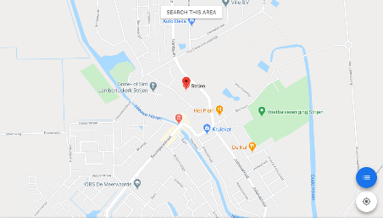
4: Do you remember any historical fact / event when you were a teenager (between 12 and 16 years old) either in India or in EU or worldwide. Why were you impressed by that event?
No.

Part 2
1: Which family matters did your parents discuss with the children when you were a teenager?: free time, studies, holidays, purchases, renovation of the house?
We talked about everything that came into our minds school, work, homework etc., I was allowed to talk about whatever I wanted.
2: What main values were taught by your parents when you were a teenager?
Don’t jump on the couch same goes for the bed. Another thing is that I was not allowed to walk with my shoes in the house.
3: Was there any hierarchy in the family (father-mother-boys-girls)? Explain.
The only hierarchy was that I had to listen what my parents said or I could go to my room, and I was not allowed to watch television for a while.
4: What did you like most in your family? Explain.
I loved sundays, because we would watch a movie with a lot of snacks, and all my grandparents would come. When our grandparents would go home again we would play games after.
5: Can you remember one very special event/occasion that you really felt the importance of being member of a family?
No special occasion or event, but I always knew that my family would always help me if I needed help with something
6: Do you think that the role of a family has changed since you were young?
When I was young your family would raise you but now it feels more equality.

