Marlene, 74yrs old

- How many people were there in your parents’ family?
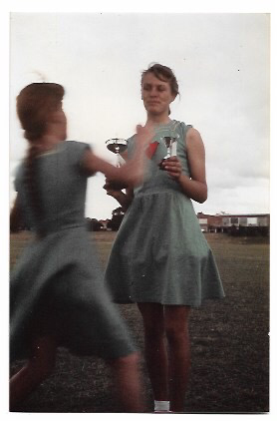
6 people
- Nuclear/Extended?
Nuclear

- What was the profession of your father and mother?
My mom didn’t work, and my dad was warehouse manager at Phillips.

- Where did you live with your parents?
We emigrated from the Netherlands to Australia when I was 5. Later, we moved back to the netherlands, to Utrecht.

- Do you remember any historical events that impressed you?
Yes, I was quite shocked when I heard about the death of John f. Kennedy. It really impressed me.

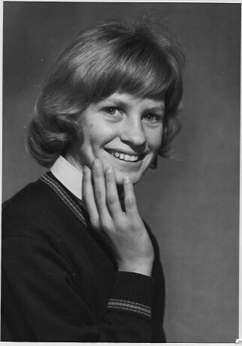
- How much time did you have when you were a teenager? School/Weekend
in school weeks, I went to school until half past three. After that, I did some homework, but not much. In the weekends, I didn’t have to do anything.

- What did you do in your free time? School/Weekend
In the schoolweeks, after dinner, I went to my friend, who lived in the same street as me. In the weekends, when the weather was nice, we went to the beach. In the weekend we went basketballing quite often. There were also jogging tournaments organized by school, 75 and 100m. I won some prices with that.

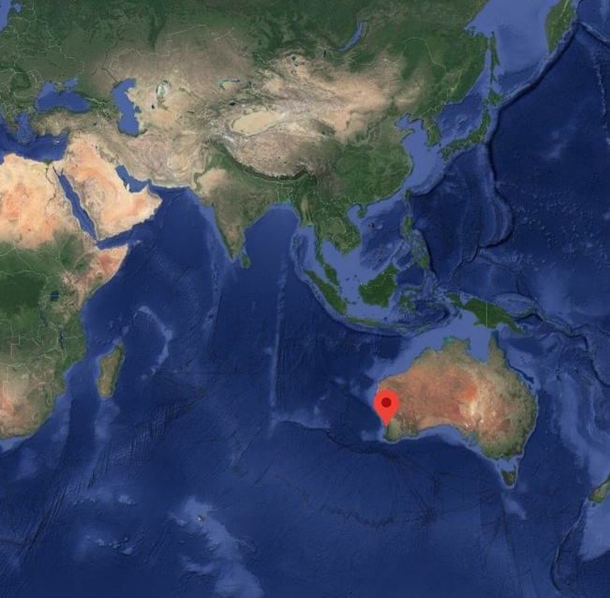
- Favorite hobby’s? Home/Outside?
I enjoyed listening to the radio, and then learning the songs with my friend, and preforming them to our parents.

- Did you have a lot of spare time, or did you have to help your parents a lot?
Yes, I had to help my parents, with laundry sometimes. Groceries too, but not cooking. School started at nine, and ended at half past three, so after that I had spare time.

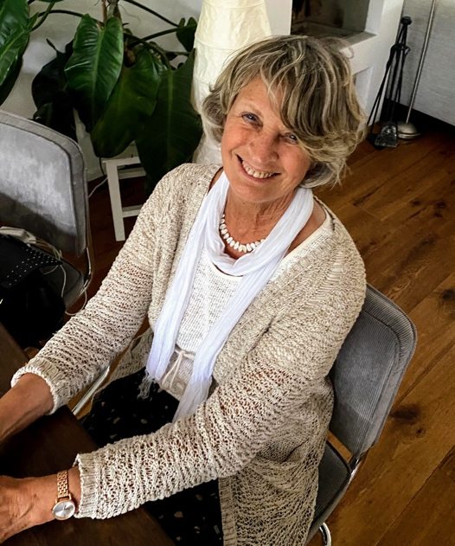
- Do you think you spent your spare time in a good way as a teenager?
Yes, considering the situation, I did. Australia is another country than the netherlands, of course. I sometimes went to the cinema with my mom, but that was it.

- Did your parents live in the countryside or in the city, and how did it influence your spare time?
We lived on the outskirts of the city. Because I am an emigrant, it did influence my use of spare time. It influenced my behavior at home, because we didn’t have any family visiting us.

- How did you get your pocketmoney? Could you spend it yourself, and how?
I got something every month. I just saved it.
- When you were young, did you spend your free time with the children who belonged to your religious and/or social background?
No, just with people in the neighborhood. My friend also was an emigrant, from Italy. I wasn’t specifically looking for emigrants to spend time with. I also was in the choir at school, and after school we stayed to practice there.

- Were there any special religious or social clubs?
I went to a catholic school, but no extra religious clubs. No english clubs too, because I learned that quite quick when I was in australia.

- Did your parents influence your spare time?
No, they didn’t.

- How much spare time did your parents have when you were a teenager?
Just the evenings. In the weekends we went to church, which we considered spare time. At home, on sundays, we always had something special to eat.

- What did they do in their free time? Their hobby’s?
In the evening, when dinner was finished. Then we just sat together, reading newspapers etc.

- Do you think that teenagers nowadays spend their spare time in a better way than when you were a teenager?
That is quite a difficult question. Now, naturally, children have much more opportunities. Teenagers could be a bit more social. In australia, we didn’t have that much technology, so we had to entertain each other.

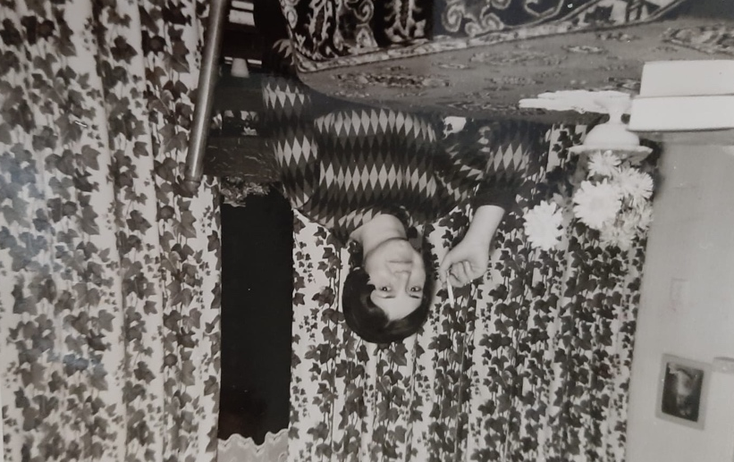
Lijnie, 71yrs old

- How many people were there in your parents’ family?
4. Inc. Parents

- Nuclear/Extended?
nuclear
- What was the profession of your father and mother?
Mom didn’t work, and my dad worked on land.

- Where did you live with your parents?
We lived outside the village, in den Bommel. We lived on a dike. The front door was on the dike, and at the back door there were stairs, and beneath that the garden.

- Do you remember any historical events that impressed you?
Yes, I remember the death of John F Kennedy. We didn’t have a television for that long, so when I saw the video, I was very shocked. I worked in the holidays, and my finger got inflamed. When I came back from work, I saw that on the television.

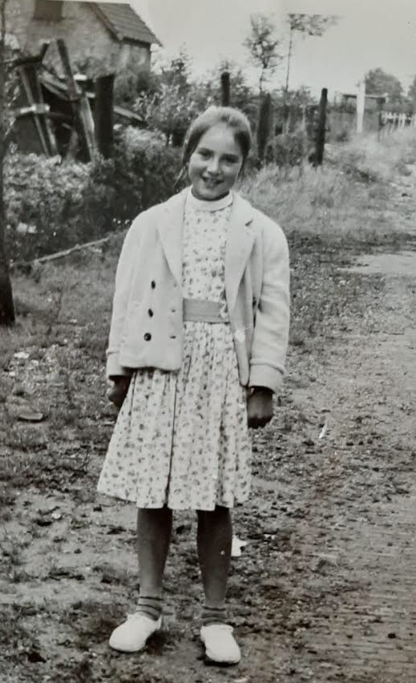
- How much time did you have when you were a teenager? School/Weekend
In the schoolweeks, school was until half past three, and after that I did some homework. In the weekend I didn’t have to do anything. I couldn’t do that many fun things, for example, the movies on saturday evening. I wasn’t allowed to go there. There was this dancing evening too. Of course, my parents wouldn’t let me go, so I told them something, I can’t remember what, and put my nice dress in a bag. Then I went there with my friend. That was quite fun.

- What did you do in your free time? School/Weekend
People always walked rounds on the dike. When you passed the church, you went by a street. The girls walked one way, and the boys the exact opposite. That’s how you ended up getting a relationship.

I also once told to guys to meet me on the dike (they didn’t know that of eachother) and there they stood, both waiting for me. Then they realized that they both wanted to meet the same girl. Me and my friend stood just around the corner, watching. It was quite funny.

- Favorite hobby’s? Home/Outside?
I didn’t have that much hobby’s. I hung around with boys a lot, that seemed like a hobby to me. I didn’t really do anything creative, except for knitting and crocheting.

- Did you have a lot of spare time, or did you have to help your parents a lot?
In the summer holidays, I did have to help my parents. They had trees in their garden, and fruit and vegetables growled there. We had to put them in plastic bags. After that, you could go.

- Do you think you spent your spare time in a good way as a teenager?
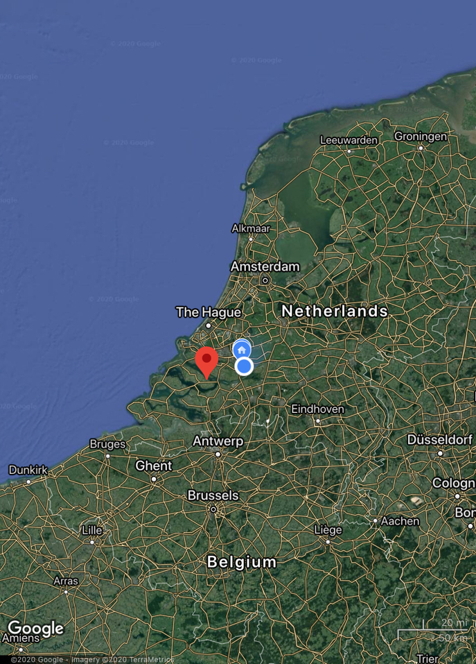
I thought I did. I liked it. If my parents shared this opinion, I don’t know, haha. But, yes, my childhood was fun.

- Did your parents live in the countryside or in the city, and how did it influence your spare time?
I lived in the countryside. Until I was six on the ‘Kranendijk’. Later in ‘Oude Tongen’, that’s where I still live now. My brother was born there, too. There wasn’t a lot to do in Oude Tongen. When I was 14, a lot of guys came to Oude Tongen. That was fun.

- How did you get your pocketmoney? Could you spend it yourself, and how?
I got it from my parents every week, and then I bought candy in the loal shop just after I got it.
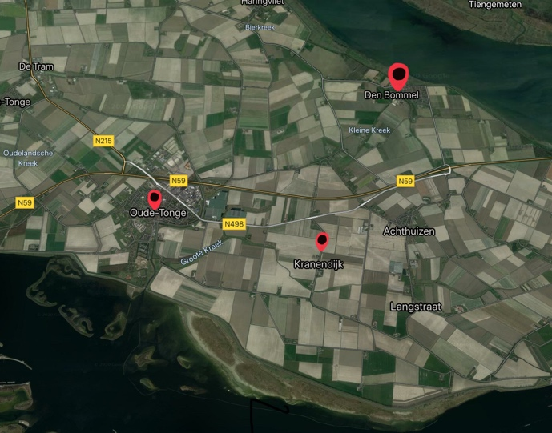
- When you were young, did you spend your free time with the children who belonged to your religious and/or social background?
I had multiple friends. One of them was Catholic. I wasn’t allowed to see her. My boyfriend was also catholic.

Another friend, Joke, had a red jacket. I really loved it. My parents said that I could have it, if I broke up with my boyfriend. I said that I did, but, of course, I didn’t. So, the next afternoon, I went with my dad to a shop, bought the jacket. And the same evening, I just went somewhere with my catholic boyfriend again!

- Were there any special religious or social clubs?
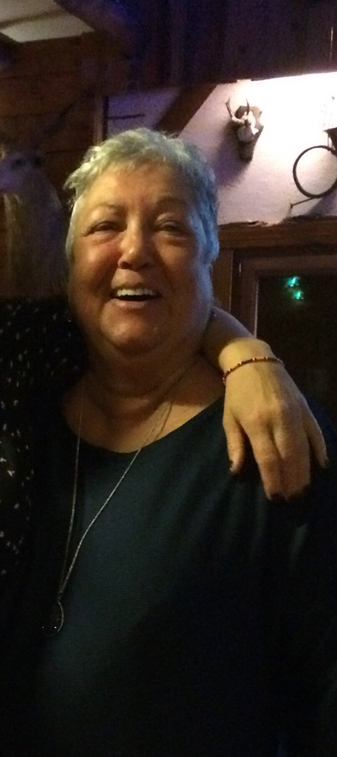
no
- Did your parents influence your spare time?
Yes, sometimes, that you weren’t allowed to go to the movies. They thought that it was nonsense. When I had a relationship with your grandfather, I was almost engaged, we went with the bust to Rotterdam, to the movies. I couldn’t stay long, so half through the movie, we went back again. I had to be home by ten. Ten, and not a minute later, they said. Then, I thought it was childish and stupid, but now when I look back at it, everyone is concerned about their children.

- How much spare time did your parents have when you were a teenager?
My dad had a lot of spare time, he went to work at 5, and got home at 5. My dad had a large barn with pigs, and my dad took care of that in the evening. My dad also had a choir, and he was conductor of the choir. My mom also had a lot of spare time, and in the evenings she would just go knitting.

- What did they do in their free time? Their hobby’s?
Knitting, creative things. My mom liked puzzles from a book.

- Do you think that teenagers nowadays spend their spare time in a better way than when you were a teenager?
Yes, now, there is a lot more to do, in this time. When I was young, I said to your grandfather, it was a lot more fun. That is not quite true, of course, because you just experience it in your own time. But now you can go out to the city and things like that. In a city, there’s a lot more to do than in a village, a lot more opportunities. It was fun, but just not a lot to do.

